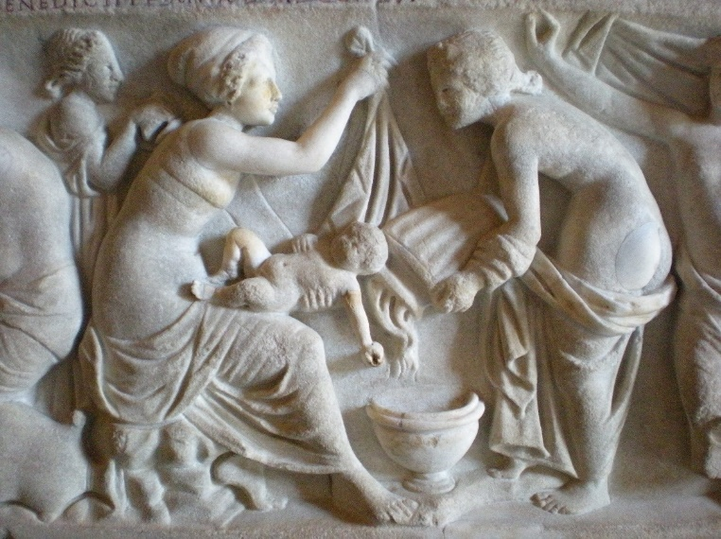
Growing up in the Roman Empire:
A multidisciplinary approach to Roman childhood
An evening event held in the beautiful World Heritage site of Durham Castle. Two talks by leading experts in Roman childhood bring together a wide range of archaeological, skeletal and historical evidence for understanding the experience, perceptions and care of children in the Roman World.
Professor Maureen Carroll (University of Sheffield)
Dr Rebecca Gowland (Durham University)
Location: The Senate Suite, University College (The Castle), Durham
Date/Time: 5.00-7.30pm, Friday 19th May
Drinks and Canapes included
For further information contact: rebecca.gowland@dur.ac.uk

Places are limited and allocated on a first come first served basis. To book a place, please send this form, together with your payment to Rebecca Gowland, Department of Archaeology, South Road, Durham, DH1 3LE. Please make cheques payable to Durham University.
…………place(s) at £15 (£10 for members of the Roman Society or SSCIP)
Total………………………………..
Name (please print clearly)…………………………………………….……
Email (for confirmation and further details)…………………………………………
