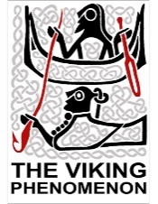
A day in the life of a Viking child: Storyboard

Arrange six different pictures of Viking children to tell a story of their everyday life. Write a sentence telling the reader what they are doing.

1.

______________________________________________________________________________________________________________________________________________________________________________________________________________________________________________________

2.

______________________________________________________________________________________________________________________________________________________________________________________________________________________________________________________

3.

______________________________________________________________________________________________________________________________________________________________________________________________________________________________________________________

4.

______________________________________________________________________________________________________________________________________________________________________________________________________________________________________________________

5.

______________________________________________________________________________________________________________________________________________________________________________________________________________________________________________________

6.

______________________________________________________________________________________________________________________________________________________________________________________________________________________________________________________

