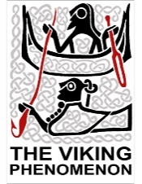
Follow up activity: show and tell

For this activity you will need to find one object that was used or worn by Viking children that still exists today. You may use books, the internet or your own toys for this exercise.

- Include a photograph of your chosen object in the below box.

- What object did you select?
______________________________________________________________________________________________________________________________________________________

- Why did you pick this object?
________________________________________________________________________________________________________________________________________________________

- How has the object changed since the Viking period? Does it look different? Is the item now made from a different material?
_________________________________________________________________________________________________________________________________________________________________________________________________________________________________

- Would Viking children have used the object differently to modern children?
_________________________________________________________________________________________________________________________________________________________________________________________________________________________________

