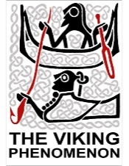
Hi ho, hi ho, it’s off to work we go!

Viking children were given lots of chores. Can you identify each work-related word in the word search?

R | Y | U | W | O | O | L | K | A
A | N | I | M | A | L | S | X | H
C | Z | D | F | G | V | P | Q | B
R | X | W | F | J | F | I | R | E
A | V | O | Z | L | I | N | L | R
F | H | O | W | J | I | N | U | R
T | K | D | M | U | D | I | D | Y
S | R | X | D | I | N | N | E | R
V | E | G | K | S | F | G | H | N

ANIMALS FIRE
BERRY SPINNING
CRAFTS WOOD
DINNER WOOL

