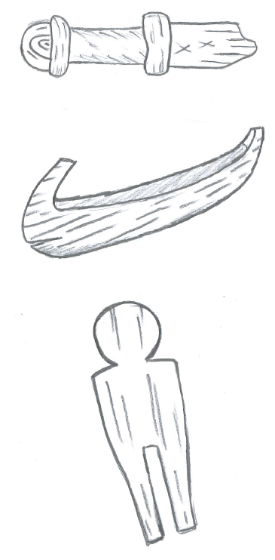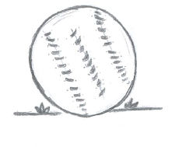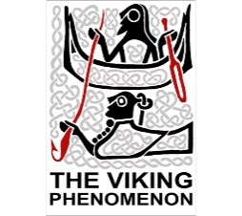

During the Viking Age, children liked to spend their free time playing with toys. Can you match the description of these Viking-Age toys to the correct picture?

A toy duck made from an animal bone

A small wooden horse

A wooden model boat

Part of a toy wooden sword

A leather ball

A wooden doll

A hnefatafl board and gaming pieces

Play time!