Teaching pack for 5-8 year olds: Children in the Viking Age

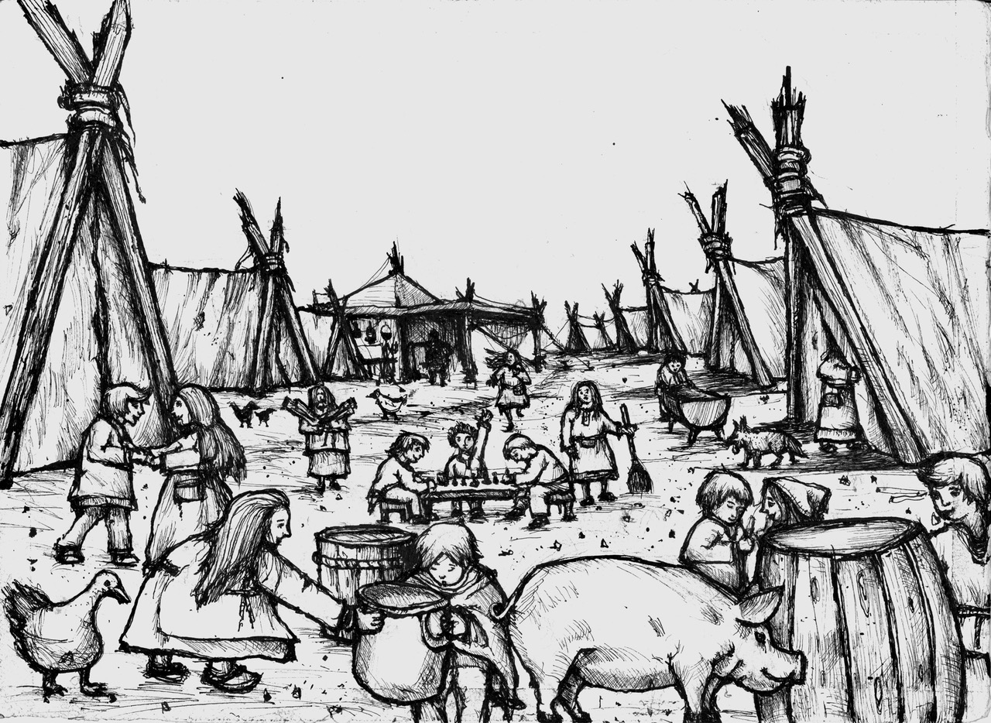

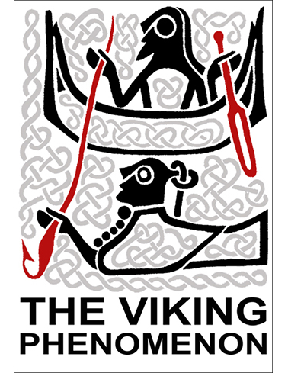
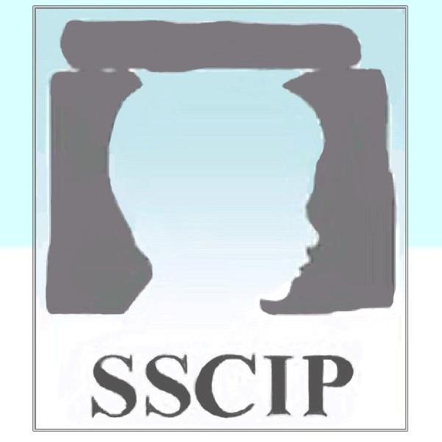

Contents

- Teaching Guide 3
  - Teaching slides 4
  - Activities 5

- Session outline 6
  - Introduction 6
  - On the move: Viking travel 6
  - The Trading Post 6
  - Dressing up! 7
  - Hi ho, hi ho, it’s off to work we go! 7
  - Write your name in runes 8
  - Play time! 8
  - A day in the life of a Viking child 8
  - Follow up activity: show and tell 9

- Glossary 11

- Useful links 15

1.0 Teaching Guide

This ‘Teaching Guide’ describes the materials and approaches associated with the ‘Children in the Viking Age’ teaching pack developed by Dr Kirsty Squires, Society for the Study of Childhood in the Past (Kirsty.Squires@staffs.ac.uk) and Dr Ben Raffield, Viking Phenomenon Project, Department of Archaeology, Uppsala University (ben.raffield@arkeologi.uu.se). Illustrations in this teaching pack were produced by Eduardo Hernandez.

This teaching pack has been designed for students aged between 5-8 years of age. The guide is intended to be read as an aid for teaching the pack. The total preparation period (including the reading of this guide and familiarising yourself with the content of this session) is not expected to exceed 175 minutes (including 30 minutes preparation), though you may wish to teach the pack based on themes covered in this pack over several sessions.

Aside from the specific aims mentioned in the teaching slides (see below), there are larger, guiding aims for the teaching pack:

- Introduce students to the Viking period, travel and trade;
- Examine the clothes and accessories children wore during the Viking Age and how social position influenced the activities children participated in;
- Explore the daily lives of children, including work, play and family life.

The teaching pack has an approximate running time of 145 minutes. See the table below for a breakdown of each section.

Teaching pack section | Slide numbers | Expected running time (minutes)
Introduction and background | 1-4 | 5
Activity 1: On the move: Viking travel | 5 | 5
Activity 2: The Trading Post | 6 | 10
Activity 3: Dressing up! | 7-11 | 30
Activity 4: Hi ho, hi ho, it’s off to work we go! | 12-17 | 20
Activity 5: Write your name in runes | 18 | 10
Activity 6: Play time! | 19-21 | 20
Activity 7: A day in the life of a Viking child storyboard | 22-23 | 30
Activity 8: Follow up activity: show and tell | 24 | 15

1.1 Teaching slides (.pptx/ .pdf)
The teaching slides can be found in the associated PowerPoint presentation. This introduces all of the background concepts relevant for successfully completing the teaching pack activities. The first four slides (1-9) introduce the topic. Slide 5 focuses upon where Vikings travelled to, whilst slide 6 addresses trade in the Viking world. Slide 7 introduces children in the Viking Age. The next four slides (8-11) contains information about children’s attire during the Viking period, which links back to the information presented on trade on slide 6. Children in the Viking period didn’t go to school but, instead, worked around the home and farm; slides 12-17 explore this topic. Slide 18 addresses the use of runes by high status children. Slides 19-21 focus upon leisurely pursuits of Viking Age children. These topics are brought together in slides 22-23 where everyday life is explored and children have the opportunity to create a “day in the life of a Viking child” story. Finally, slide 24 details the follow up activity students will need to complete before the next session. Each of these topics will be accompanied with activities and discussions.

The majority of information that should be communicated to the students is written directly on the slides. Key terms are coloured red and bolded. Where key terms are found in the “Notes” section on PowerPoints, these words are coloured black and bolded. Definitions of these key terms can be found in the Glossary (section 4.0 of this teaching pack). On some occasions, there is additional instruction or information in the “Notes” field within the PowerPoint file. Please feel free to use your own words as you communicate the information outlined on the slides and notes. Asking the students questions throughout the PowerPoint is highly recommended (some examples of these can be found on the PowerPoint slides).

Information relating to the descriptions of images used on the slides is contained within the ‘Notes’ field. The sources of all images are listed in the “Notes” section at the bottom of each slide on the PowerPoint presentation.

1.2 Activities (.docx/ .pdf)
Each activity is outlined below. Further details can be found in the “Notes” section at the bottom of the associated PowerPoint and the worksheets. A list of materials needed for each activity is also provided in the following teaching pack.

2.0 Session outline

2.1 Introduction
Slides 1-4: Discuss what will be covered in the session. Additional prompts and notes can be found in the “Notes” section at the bottom of the PowerPoint.

2.2 On the move: Viking travel
Slide 5: For the map activity, ask students to identify different countries the Vikings travelled to using the map on the screen. This will lead on to the next slide and activity whereby the students will consider Viking trade.

Map of Viking travels:
Viking groups travelled to and made new homes in the British Isles (England, Wales, Ireland, Scotland, and the Isle of Man), Germany, France, Spain, Italy, eastern Europe and Turkey, Russia, the Ukraine, the Faeroe Islands, Iceland, Greenland, and Canada (Newfoundland).

2.3 The Trading Post
Slide 6: Proceed to explain the different goods that were traded, where they came from, and ask students what they think each item was used for, e.g. they traded wool for clothing, furs for clothing, reindeer antler for combs and decorative items, fish for food, and walrus ivory for jewellery. In return they bought jewellery, amber for jewellery, silver for coins and jewellery, wine for drinking, spices for food, and pottery for storage. Students should complete the “Trading Post” worksheet as you discuss each object type.

For this exercise you will need:
- A4 print outs of the “Trading Post” worksheet
- Pencils

Later, you will think about how children interacted with these traded goods, e.g. the clothes they wore and the food they prepared and consumed.

2.4 Dressing up!
Slides 7-10: Proceed to discuss clothing in the Viking Age. Further prompts and discussion points can be found in the “Notes” section at the bottom of the PowerPoint.

Slide 11: The “Dressing up” activity will involve students colouring in the accessories and clothes of the Viking children and adults. Ask students to start by colouring in the children and then move on to the adults. Following this exercise, ask the students to “show and tell”. Ask students to explain why they picked the colours used in their images. The latter part of this activity should take five minutes.

For this exercise you will need:
- A4 print outs of the “Dressing up” worksheet
- Colouring pencils

2.5 Hi ho, hi ho, it’s off to work we go!
Slide 12-17: These slides will focus on Viking children and work. Further prompts and discussion points can be found in the “Notes” section at the bottom of the PowerPoint. Before telling students about the type of work in the Viking Age on each slide, ask them to identify what the children are doing in the image, e.g. helping with cooking.

After slide 17, before moving on, ask student to complete the “Hi ho, hi ho, it’s off to work we go!” activity. This word search contains key words relating to children’s work in the Viking Age. Each of these words has been discussed in this section of the PowerPoint.

For this exercise you will need:
- A4 print outs of the “Hi ho, hi ho, it’s off to work we go!” worksheet
- Pencils

2.6 Write your name in runes
Slide 18: This slide briefly explores the use of runes in the Viking Age. Children did not attend school but high-status children may have been taught to read runes. Further prompts and discussion points can be found in the “Notes” section at the bottom of the PowerPoint.

After slide 18, before moving on to slide 19, ask students to write their names in runes using the “write your name in runes” activity sheet.

For this exercise you will need:
- A4 print outs of the “Write your name in runes” worksheet
- Pencils

2.7 Play time!
Slide 19-21: These slides focus on children’s past times. Many of the activities that children participated in during the Viking Age prepared them for adulthood. Further information, prompts and discussion points can be found in the “Notes” section at the bottom of the PowerPoint.

After slide 21, before moving on to slide 22, ask students to complete the “play time” activity work sheet. Here, students will need to match images of different recreational activities with the corresponding description.

For this exercise you will need:
- A4 print outs of the “Play time” worksheet
- Pencils

2.8 A day in the life of a Viking child
Slide 22: Inform students of different types of dwellings that Viking children lived in. Further information, prompts and discussion points can be found in the “Notes” section at the bottom of the PowerPoint.

Slide 23: Now that you have covered all aspects of Viking childhood, this slide will bring many of the themes (e.g. work and play) together. The slide shows an artist’s impression of children living in Torksey, a Viking camp in Lincolnshire, England. Ask children what activities they can spot and the number of animals they can identify. Further information, prompts and discussion points can be found in the “Notes” section at the bottom of the PowerPoint.

After completing the activity on slide 23, the final in-class activity will require students to make a storyboard of the life of a Viking child. From the “A day in the life of a Viking child” resource sheet, you will need to cut out each image prior to the start of the session. Students will need to select six images and glue them on to the “A day in the life of a Viking child” storyboard worksheet. They can use their imagination and mix and match images. Students will then need to write what the children (in the images) are doing under each picture on the storyboard.

At the end of the activity ask students what the children are doing and why they have put the images in the order they have selected. Also ask how each of these activities differ (or are similar) to modern day activities of children, e.g. do children still play board games?

For this exercise you will need:
- A4 print outs of the “A day in the life of a Viking child” resource sheet (one per student) – cut these up prior to the session to save time in class
- A4 print outs of the “A day in the life of a Viking child” storyboard worksheet (one per student)
- Glue sticks
- Pencils

2.9 Follow up activity: show and tell
Slide 24: To conclude this teaching pack, students will need to complete a follow up activity (homework). Students will need to use books, the internet or your own toys to find one object that was used or worn by Viking children that still exists today. They will need to complete the “Follow up activity: show and tell” worksheet. They may bring the object (if available) to the next session or stick a photograph of the object on to the worksheet. Students will need to think about how these objects have changed over time (materials, function, appearance, etc.).

For this exercise you will need:
- A4 print outs of the “Follow up activity: show and tell” worksheet

The follow up discussion in the next session should take no longer than 15 minutes. Some discussion points include:
- What object did you select and why?
- How has this changed since the Viking period?
- Would Viking children have used the object differently (e.g. a tool/training aid instead of a toy, such as a small sword)?

3.0 Glossary

Amber: Amber is a material made from fossilized tree resin which sometimes contain the remains of insects, such as mosquitos, and spiders. This material was obtained from the Baltic Sea region and was typically used in crafts, such as jewellery making.

Archery: Archery was a common skill (and sport) practiced by the Vikings and involves shooting arrows from a bow. Longbows were used during the Viking Age.

Fish: The Vikings ate different types of fish at home and whilst on their travels. Freshwater fish (e.g. eel and trout) were often caught in European lakes, whilst fish from the ocean (e.g. cod, salmon, and herring) were typically caught from the North Sea, Baltic Sea and North Atlantic Ocean. The Vikings also hunted whales and other large sea mammals!

Furs: Fur from foxes, bears, hares, sable, and wolves were used for clothing in the Viking world. These were often traded and worn by individuals belonging to high status families.

Glima: A form of wrestling; this form of martial arts is still practiced in modern-day countries in Scandinavia.

Hnefatafl: A Viking board game similar to chess whereby a king and his retainers fight an army. Archaeologists have yet to find any written rules of this game but it is thought that the aim of the game was to capture the ‘king’ piece, like in modern-day chess. Archaeologists have found playing pieces made from wood, stone, and whale bones, and images of figures playing hnefatafl have been found on memorial stones. This game disappeared in the middle ages.

Jewellery: Viking Age Jewellery was made from precious metals e.g. silver, and precious stones, e.g. garnets from India and the Middle East, carnelian from India, jet from the British Isles, and amethyst from eastern and southern Europe were traded, among others. Jewellery was typically worn by adults, though higher status children would also wear these accessories.

Linen: Linen was typically made from flax and normally undyed as it is difficult to dye linen.

Long bow: Long bows were used in archery. They were made from wood, often elm, yew or ash, and measured almost two metres in length. It would require lots of training for someone to build up the strength to use these bows properly.

Pottery: Pottery was traded by Vikings on their travels. These objects were obtained from modern-day France and Germany, and from the southern Baltic. Most Vikings did not use pottery, but when they could obtain it they used it for storing goods and as dinnerware.

Reindeer antler: Antler from reindeers, reared in Scandinavia, was often traded and crafted into jewellery and decorative items.

Runes: Runes were a system of writing, devised from Germanic languages. The alphabet (known as the futhark) comprised of 22 letters and can be found on memorial stones in the UK, Ireland and Scandinavia, and runic messages have also been found inscribed on pieces of wood and bone, as well as on jewellery and weapons. High status children were taught to read runes and they may have been thought to possess magical properties.

Saga: Sagas were tales that detailed Viking histories, travels, battles and feuds. These stories were first written down during the Middle Ages, several centuries after the end of the Viking Age. So, we cannot be sure whether they give us a realistic picture of Viking-Age life.

Seafarer: A seafarer is a person responsible for navigating boats or assisting in the maintenance and running of a boat. Seafarers are also known as mariners and sailors.

Silver: Silver was obtained mostly from the Middle East (modern-day Iraq and Iran, and the countries nearby), and was used both as a form of payment and for making jewellery. For most of the Viking Age, people in Scandinavia did not use money – instead, silver was weighed out using scales and balances, in order to buy things.

Soapstone: A metamorphic rock, containing a high proportion of mineral talc. This was often used to make bowls in the Viking period.

Spices: The Vikings used lots of spices from Scandinavia, such as dill, caraway, wild garlic, and mustard seeds. They may have also had access to more exotic spices such as cinnamon, ginger, and nutmeg, which could have been obtained (in small amounts) from the east through trade.

Spindle whorl: A spindle whorl is a perforated weight that helps the spindle rotate when spinning fibres. Viking Age whorls were typically spherical in shape and were made from bone, ceramic, stone and wood.

Spinning: Spinning fibres into yarn, or thread, allowed Vikings to make fabrics and, in turn, clothes (via the process of weaving). Initially, wool was combed before a drop spindle was used to create the yarn or thread. The yarn would then be woven using a loom.

Walrus ivory: Walrus tusks (ivory) were obtained in the Arctic and the North Atlantic e.g. Greenland and Iceland. Walrus ivory was used to make gaming pieces and jewellery.

Wattle and daub: Wattle and daub is a building material used for building walls. A wooden frame in the form of a lattice (wattle) is filled with daub, which is made from soil, animal dung, sand and straw.

Weaving: Vertical (or upright) weaving frames were used to weave threads or yarn into clothing and other textiles, such as bedding, tapestries, and sails. This was a highly-skilled process, and probably occupied a lot of time.

Weaving sword: Weaving swords were made of bone and metal, normally iron. These objects were used to beat transverse threads (weft) when weaving on a vertical loom.

Wine: Wine from southern Europe and the Mediterranean was traded for drinking.

Wool: Wool was sheared from sheep in countries in northern Europe, such as Sweden, Norway, and the UK. Wool was an important material, as it is waterproof properties made it very useful for sailors and merchants travelling in open ships. Wool was subsequently woven into clothing and other articles, such as sails. Any extra products could be traded with other households or taken overseas.

4.0 Useful links

National Museum of Denmark: https://en.natmus.dk/historical-knowledge/denmark/prehistoric-period-until-1050-ad/the-viking-age/

Jorvik Viking Centre: https://www.jorvikvikingcentre.co.uk/

Society for the Study of Childhood in the Past: https://sscip.wordpress.com/

The Viking Phenomenon Project: http://www.arkeologi.uu.se/Research/Projects/viking-phenomenon/

The Viking Ship Museum, Oslo, Norway: https://www.khm.uio.no/english/visit-us/viking-ship-museum/

