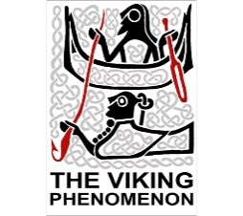**The Trading Post**

Vikings traded different goods in return for exotic items. What did the Vikings trade? What were these objects used for?

|  |  |  |
| --- | --- | --- |
| **Image of goods** | **Name of goods** | **How was the good used?** |
| Related image |  |  |
|  |  |  |
|  |  |  |
|  |  |  |
|  |  |  |
|  |  |  |
| Image result for amber clip art |  |  |
|  |  |  |
|  |  |  |
| Image result for pottery clip art |  |  |
|  |  |  |