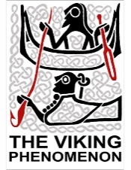
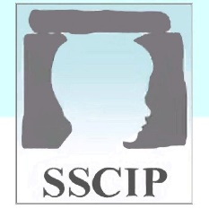
Write your name in runes

High status children were taught how to read runes. Use the Viking runes, to spell out your name.

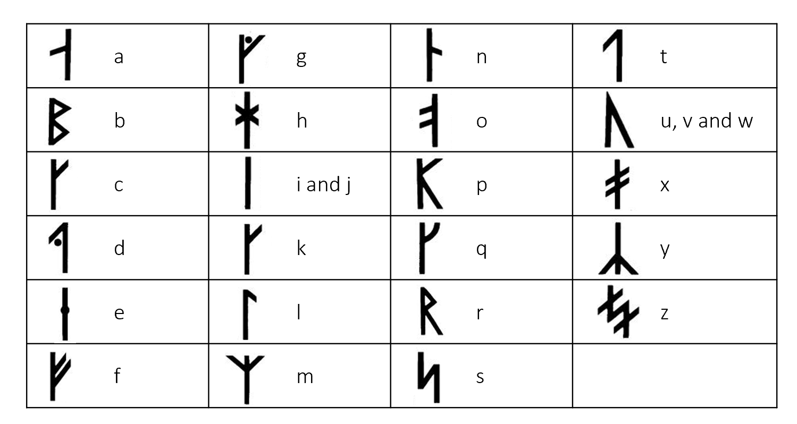

Spell your name in English___________________________________

Spell your name using runes_________________________________

